Advanced Phishing Detection System Using Hybrid AI Models

Project-1 Synopsis

Submitted in partial fulfillment for the award of the degree
Of
Bachelor in Technology
In
Computer Science & Engineering



Submitted by:
Suhail Kataria (2417163)
Arpita Choudhary (2320457)
Rimjhim Sharma (2320487)

Department of Computer Science & Engineering CGC-College of Engineering
Landran, Mohali Session: 2023-24
CERTIFICATE

Certified that Project work entitled Advanced Phishing Detection System Using Hybrid AI Models is a bonafide work carried out in the 6th semester by Suhail Kataria (2417163), Arpita Choudhary (2320457) and Rimjhim Sharma (2320487) for Project-1(BTCS 603-18) as a part of Bachelor of Technology in Computer Science & Engineering at CGC- College of Engineering, Landran from I.K.Gujral Punjab Technical University, Jalandhar.

Date: Signature of Students

This is to certify that the above statement made by the candidate is correct to the best of my knowledge.

Date: Signature of Supervisor
Ms. Nidhi Bhatla

ACKNOWLEDGEMENT

We would like to express our sincere gratitude to the Director-Principal, CGC College of Engineering, Landran, for providing this opportunity to carry out the present work.
The constant guidance and encouragement received from Head, Department of Computer Science and Engineering, Landran has been of great help in carrying our present work and helped me in completing this project with success.
We would like to express a deep sense of gratitude to my Project Supervisor Ms. Nidhi Bhatla, CSE department for the guidance and support in defining the problem and towards the completion of our project work. Without her wise counsel and able guidance, it would have been impossible to complete the project in this manner.
We are also thankful to all the faculty and staff members of the Department of Computer Science and Engineering for their intellectual support throughout the course of this work.

Suhail Kataria (2417163)
Arpita Choudhary (2320457)
Rimjhim Sharma (2320487)

ABSTRACT

Today, this has been made possible by modern digital communication technologies that make it easier to communicate and access information online. However, this has also made people more vulnerable to cyber attacks like phishing attacks that seek to trick people using fake websites or emails. In these attacks, cyber attackers often mimic real websites or emails with the aim of acquiring sensitive information like login credentials or personal information.
So, This project seeks to create a hybrid phishing detection system that uses multiple artificial intelligence techniques to identify malicious URLs and suspicious emails. This detection system will seek to improve the accuracy of detecting phishing attacks and enable people to identify potentially harmful threats more effectively.
After, The features that are obtained from the process of detecting phishing attacks are then analyzed to ascertain whether the input is legitimate or not. This approach to detecting phishing attacks has been improved to ensure that people can be better protected from potentially harmful threats.
List of Contents

Chapter | Description | Pg. No.
 | Certificate | i
 | Acknowledgement | ii
 | Abstract | iii
1 | Introduction | 1-4
2 | Feasibility Study | 5-7
3 | Literature Survey | 8-10
4 | Methodology | 11-16
5 | Facilities Required | 17
 | References | 18

CHAPTER 1

INTRODUCTION

1.1 Background

In the previous years, we have seen that the rapid development of digital communication has led to a noticeable rise in the number of cyber attacks targeting individuals and organizations. Among the various types of attacks, phishing attacks are considered to be the most harmful type of cybercrime. Phishing is a type of attack where attackers trick the users into divulging sensitive information, such as login credentials, financial information, or other personal information. Phishing attacks are commonly carried out through malicious emails, misleading websites, or misleading links that closely resemble legitimate online platforms.
In the past few years, it has been observed that the nature of phishing attacks has become more sophisticated. Earlier, it was easy to identify phishing attacks, as attackers would send malicious emails or use misleading links. However, it has been observed that attackers are now using more sophisticated phishing attacks. They are creating phishing attacks that closely resemble legitimate online platforms. They are using domain names, webpage designs, or email messages that closely resemble legitimate online platforms. They are creating email messages that urge the users to act immediately, thereby tricking the users into divulging sensitive information.
Phishing attacks can be detected using different detection systems. Earlier, it was possible to use the blacklist-based detection system, where the system would filter the malicious websites based on the predefined rules. However, it has been observed that attackers are creating new domains or modifying the URL structure to bypass the detection mechanism.
However, in the last decade or so, machine learning techniques have started to play an important role in the field of cybersecurity, including phishing detection. Machine learning techniques have the ability to analyze the patterns in URLs, domains, and content to identify suspicious behavior. Machine learning techniques have the ability to learn from the patterns in the dataset of phishing websites and legitimate websites.
However, the existing phishing detection systems have shown significant shortcomings. A significant number of the existing systems use only one type of data source for detection. These systems may use the structure of the URLs or the content of the emails. There is a need to use multiple data sources for the detection of phishing websites. Moreover, the machine learning techniques used in the existing systems are considered to be black box techniques. These techniques have the ability to make predictions but cannot provide explanations for their predictions. This may cause a loss of confidence for the cybersecurity experts.

However, the need to use multiple data sources for the detection of phishing websites is being met by the development of hybrid phishing detection systems. These systems have the ability to use multiple data sources for the detection of phishing websites. These systems use multiple data sources to provide a better perspective on the problem. These systems use multiple data sources for the detection of phishing websites. These systems use multiple data sources to provide a better perspective on the problem.

1.2 Problem Statement
Phishing is a significant problem in the field of cybersecurity. Phishing is an online crime where attackers target individuals, organizations, and government agencies to steal their confidential information. One of the main reasons for the difficulty in preventing phishing is the creation of new phishing websites. These phishing websites are created in a short time and remain active for only a short time.
Another challenge that has been presented by the increasing sophistication of phishing URLs and domains is the fact that hackers often create domains that resemble legitimate sites by making minor changes to the spelling or by using character substitution or Unicode tricks. These tricks make it difficult for users or detection algorithms to differentiate between legitimate sites and phishing sites.
Several machine learning-based techniques were also proposed to solve the problem by analyzing the features derived from the URLs or the content of the sites. Though the techniques were successful to a certain extent, they were often challenged by the limitations of increasing false positives, the need for static training sets, and the fact that they were not effective against the newly emerging phishing attacks. Moreover, the techniques were also not capable of providing any information about the factors that were used to classify the sites as legitimate or phishing sites.
Another limitation that has been noted with the majority of the phishing detection techniques is the lack of integration with multiple information sources. For example, the techniques often concentrate on analyzing the structural features of the URLs while ignoring other relevant features such as the reputation of the domains or the context contained in the email message from where the phishing URL originated.
As a result, there exists a high need for a comprehensive phishing detection system that can incorporate various pieces of evidence from different sources, including URL features, domain intelligence, and email content analysis. Moreover, the system should be capable of producing understandable results to help security researchers comprehend the reasons behind the detection of a particular link as a phishing threat.

1.3 Approached Solution
In order to effectively address the limitations of the various phishing detection techniques that have been presented so far, the proposed project aims to develop an AI-based hybrid phishing detection system that incorporates various analytical components into a single system. The system will be capable of evaluating suspicious links by making use of machine learning algorithms, domain intelligence techniques, and AI methods.
In the first place, the system will be designed to incorporate the three key components of a phishing detection system, namely URL analysis, domain intelligence evaluation, and email content analysis. To achieve this, the system will be designed to analyze the various characteristics of a given URL, including the lexical features of the URL. Some of the key characteristics of a URL that the system will be capable of analyzing include the length of the URL, the entropy of the URL, the presence of suspicious tokens in the URL, and the structural pattern of the URL, among many others. These characteristics will be analyzed by machine learning algorithms that can differentiate between legitimate and phishing URLs.
In addition to the above analysis, the system will also be designed to incorporate a module for evaluating the credibility of a given domain name. To achieve this goal, the system will be capable of evaluating various characteristics of a given domain name, including the reputation of the domain name, the similarity of the domain name to other well-known brand names, and the pattern of the domain name.
Another component of the system includes a planned email analysis module, which uses natural language processing to examine the content of phishing-related emails. This includes the analysis of factors like the subject line of the email, the body of the message, and any included links to determine the persuasive strategies employed, including factors like urgency, authority, and money.
All these components are integrated through a hybrid fusion mechanism that provides a phishing risk score along with the explanations of the factors that influence the decision. This ensures that the accuracy of the detection is improved while false positives are minimized.

1.4 Objectives
The objectives of this project are given below:
- To create a phishing detection system that uses a machine learning approach to accurately identify malicious URLs.
- To create a hybrid phishing detection framework that can integrate URL analysis, domain intelligence evaluation, and email content analysis within a single framework.
- To reduce the false positives associated with phishing detection by including mechanisms that can verify domains and assess their reputations.
- To create a detection mechanism that can identify advanced phishing techniques like brand impersonation and the use of lookalike domains.
- To create a mechanism that can provide explanations of the factors that influence the detection of phishing.
- To create a scalable architecture that can fit within web security infrastructure.

1.5 Scope
The scope of the project is based on creating an intelligent phishing detection system that can analyze the suspicious link information using machine learning techniques. It mainly focuses on analyzing the URLs and domain information obtained from publicly available datasets, including phishing URLs and legitimate domain records.
This system can be used mainly as a research tool or for experimental purposes and can be used as a prototype to implement real-world security applications. It can be used as an extension or an addition to existing web browsers or email gateways to help detect suspicious URLs before accessing the link.
Although the system can be used to detect different types of phishing attacks, it is not meant to replace existing security systems such as secure email gateways or other security systems used to protect against threats online. It is an intelligent system that can be used as an extension or an enhancement to existing security systems.
There are several future enhancements that can be made to the project, including real-time phishing detection, using live feeds to enhance the system's capabilities, and using the system as a cloud-based security service that can analyze and monitor URLs and emails.

CHAPTER 2

FEASIBILITY STUDY

2.1 Technical Feasibility
Technical feasibility is concerned with the possibility of the system being implemented given the tools and technology available in the present environment. For the phishing detection system in the proposed project, the system can be implemented using various machine learning frameworks and programming tools that have been widely accepted in the field of cybersecurity.
At the heart of the phishing detection system is the use of various machine learning models to analyze the patterns of URLs or characteristics of domains. These machine learning models can be implemented using widely accepted Python programming libraries like Scikit-learn, NumPy, and Pandas. These libraries have efficient capabilities for data preprocessing and training of the machine learning models. Moreover, the system can use natural language processing models like DistilBERT for the analysis of the content of emails.
At the backend of the phishing detection system is the use of FastAPI to build APIs for the system. FastAPI is a Python-based framework that is efficient in the development of APIs for real-time systems. The frontend of the phishing detection system is built using Next.js and Tailwind CSS. These two tools have efficient capabilities for the development of responsive web-based systems.
The dataset for the development of the phishing detection system is publicly available. For the development of the phishing detection system, the dataset of phishing URLs can be obtained from various publicly available datasets like PhishTank. On the other hand, the dataset of legitimate domains can be obtained from publicly available datasets like the Tranco dataset for the top-ranking domains.
In addition to that, the computational needs of the project can be easily met with the available hardware resources that are common in computers. As such, the technical infrastructure that is needed to design, develop, and test the system is readily available.

2.2 Operational Feasibility
The process of operational feasibility is aimed at designing and developing how well the system can function in real-world settings. In this case, the phishing detection framework is aimed at creating a system that can be used as a tool by users or security experts to determine whether a given link is safe or not. This is achievable since the system is designed as a tool that can be used to verify whether a given link is safe or not.
In this case, the system can be used as an additional tool that can help security experts or users in understanding whether a given link is safe or not. This is achievable since the system can be used as a tool that can help users or security experts in understanding whether a given link is safe or not. This is achievable since the system can be used as a tool that can help users or security experts in understanding whether a given link is safe or not.
Another factor to be taken into consideration for the feasibility of the system is usability. The system focuses on the interpretability of the results by providing explanations for the predictions made by the system. This level of transparency allows users to understand the reasoning behind the classification made by the system.
Additionally, the system is designed with a modular architecture that allows new detection modules to be incorporated in the future without having to significantly modify the overall framework. This ensures that the system can evolve as the nature of phishing attacks continues to change.

2.3 Economic Feasibility

Economic feasibility assesses whether the project can be implemented at an affordable cost. In this case, the development of the phishing detection system is considered to be economically feasible since it mainly involves open-source technologies and datasets.

To start with, the programming language used in developing the system is open source and widely accepted by the global programming community, especially in the development of machine learning models. In the same way, the open-source nature of the machine learning frameworks like Scikit-learn, TensorFlow, and PyTorch is advantageous since they offer extensive tools for developing predictive models.

Regarding the datasets used in developing the phishing detection models, they are also freely available online. For example, the datasets containing information on phishing URLs can be obtained from PhishTank, while those containing information on legitimate websites can be obtained from datasets like the top ranking domains using the Tranco top domain ranking datasets.

Regarding the infrastructure costs involved in developing the system, they are considered to be very low since the project can be implemented using personal computers without having to invest in expensive hardware infrastructure.

As the system is a software-based system, the long-term economic benefits are considerable. It helps the organization to save money from potential phishing attacks and protect the data and the reputation of the organization. Therefore, the potential benefits of the system are considerable compared to the cost of development.

2.4 Schedule Feasibility
Schedule Feasibility evaluates the project schedule to determine whether the project could be completed within the time allocated to the academic semester. Since the proposed system for phishing detection is based on the development of the system through the modular approach, different components of the system could be developed and tested separately.
As discussed earlier, the initial phase of the project involves the collection and preprocessing of the dataset. This includes the collection of phishing URLs and the collection of lists of legitimate domains, preprocessing the collected data, and the development of feature extraction pipelines for the data collected during the initial stage of the project.
The second phase of the project involves the development of the models for the detection of URLs through the application of machine learning algorithms and the evaluation of the developed models through the application of appropriate metrics to the developed models.
The third phase of the project involves the development of a hybrid model for the detection of phishing URLs through the application of multiple sources of information to develop a phishing score for the URLs provided to the system.
Finally, the fourth and the last phase of the project involves the testing and evaluation of the developed system through the application of appropriate metrics to determine the performance of the developed models.
As the datasets and the tools are already available, the implementation process could be carried out without any considerable delay.

CHAPTER 3

LITERATURE SURVEY

3.1 Overview of Existing Research
Phishing is considered to be one of the most commonly encountered forms of cybercrime on the internet today. Phishing attacks are carried out through various deceitful practices such as fake websites, malicious links, and phishing emails, wherein users are tricked into revealing their sensitive information to attackers. As phishing attacks are highly dependent on social engineering and imitation of legitimate websites, their detection using artificial intelligence techniques has become a prominent area of research in recent years.
In earlier days, phishing detection techniques were highly dependent on rule-based systems containing a list of known phishing websites. Though these techniques were useful in detecting known phishing websites, they were not useful in detecting phishing websites that were not yet identified by researchers. As phishing attacks are highly dynamic in nature, researchers have now started using machine learning techniques to detect phishing websites.
Recent studies have revealed that artificial intelligence plays a prominent role in enhancing phishing detection techniques. Machine learning techniques are capable of detecting phishing attacks by analyzing various characteristics associated with phishing attacks, such as URL structure, webpage attributes, email content, and domain reputation factors. Comparative studies on various artificial intelligence techniques in phishing detection have revealed that machine learning and deep learning techniques are capable of providing a high level of accuracy in phishing detection when compared to rule-based phishing detection techniques.
Another prominent area of research in phishing detection is email content analysis. Phishing emails are sent to users using various deceitful practices such as email content, email attachments, and sender behavior. Machine learning techniques are employed in artificial intelligence systems to automatically detect these deceitful practices in phishing emails. Studies on artificial intelligence in phishing email detection have revealed how machine learning techniques are employed in phishing email detection techniques to differentiate legitimate emails from phishing emails.
In addition to this, URL-based detection methods have been the subject of much research. As it is commonly known that phishing attacks use misleading URLs that resemble legitimate sites, there has been much research done to develop models for the analysis of URL features. Domain length, the presence of suspicious characters, unusual path structures, and the use of excessive subdomains are the features that are commonly used for the development of machine learning classifiers for the detection of phishing sites.
Several research studies have been conducted to develop hybrid models for the detection of phishing sites. Unlike other detection methods, hybrid models combine the results of different analytical techniques such as URL feature analysis, domain analysis, and machine learning-based classification. By using the results of different analytical tools, the accuracy of the detection mechanism is improved, thereby reducing the rate of false positives.

3.2 Summary of Related Research:

S.No | Research Study | Approach | Key Contribution
1 | AI Based Phishing Detection Techniques: A Comparative Analysis of Model Performance. | Comparative evaluation of ML and DL models. | Demonstrates improved phishing detection accuracy using AI-based techniques.
2 | The Role of Artificial Intelligence in Detecting and Preventing Phishing Emails. | Machine learning and NLP for email analysis. | Shows how AI analyzes email content, metadata, and sender behavior to identify phishing attempts.
3 | Hybrid Machine Learning Model for Phishing Detection. | Hybrid ML models combining multiple classifiers. | Improves detection accuracy through ensemble learning techniques.
4 | Phishing Detection System Through Hybrid Machine Learning Based on URL. | URL-based feature extraction with hybrid ML model. | Aimed on structural URL analysis to identify phishing websites.
5 | Across the Spectrum: In-Depth Review of AI-Based Models for Phishing Detection. | Comprehensive survey of AI phishing detection methods. | Reviews strengths and limitations of no. of ML and DL techniques.
6 | Deep Learning Approaches for Phishing Detection (Electronics-12-00232) | Deep neural networks and feature learning. | Shows improved performance using deep learning architectures.
7 | AI-Based Phishing Detection and Student Cybersecurity Awareness in the Digital Age. | Machine learning framework for phishing classification. | Presents dataset-driven phishing detection pipeline.

3.3 Limitations in Existing Systems
Though researchers have made tremendous advancements in phishing detection techniques, some issues are still not addressed in existing systems. Some of these issues are as follows:
Most of the existing phishing detection systems rely on a single data source, such as URL or email text. However, this limitation makes these systems ineffective against modern phishing attacks, where attackers use a combination of different techniques to attack users.
Another limitation commonly found in existing systems is their reliance on static data sets. Phishing strategies are constantly evolving, and it is difficult to predict these strategies using data sets containing outdated information.
Most machine learning techniques are considered black box classifiers, meaning they do not provide any explanation for their detection decisions, even though they are highly accurate in detection effectiveness. In a real-world scenario, a certain level of transparency is required in a system to understand why a particular site or email is marked as malicious.
In addition to that, attackers are increasingly using techniques like domain impersonation attacks, which include homoglyph attacks and lookalike domains. There are a number of phishing detection systems that do not take these sophisticated attacks into consideration, which allows attackers to evade detection.

3.4 Motivation for the Approached System

All the problems that were identified with the existing research clearly point to the fact that there is a need to create a more comprehensive phishing detection framework.

In that regard, the system has adopted a hybrid approach that uses more than one information source to improve the accuracy of the detection process.

In that regard, the system has used a combination of URL-based feature analysis, machine learning classification techniques, and domain intelligence to improve the detection process.

In addition to that, the fact that the system uses more than one detection mechanism ensures that the accuracy of the detection process is improved while at the same time reducing the number of false positives that may occur.

In addition to that, the fact that the system has been developed with the ability to accommodate more detection mechanisms ensures that the system can keep up with the changing nature of phishing attacks while at the same time ensuring that the system can operate within a real-world environment.

CHAPTER 4

METHODOLOGY

4.1 Overview of the Approached System
In this system development project, a system for detecting phishing attacks by analyzing the information from two main sources, i.e., URLs and email messages, is presented. Generally, phishing attacks involve the sending of malicious links to the email accounts of the targeted users. These links usually redirect the users to false sites. By analyzing the URL structure as well as the content of the message sent to the users through the email, the system can easily identify the warning signs that indicate a phishing attack.
In most cases, phishing attacks involve the sending of false URLs to the email accounts of the targeted users. These false URLs usually redirect the users to false sites. To counter this problem, the system analyzes the URL as well as the content of the message sent to the users through the email. By analyzing the content of the message sent to the users through the email, the system can easily identify the warning signs that indicate a phishing attack.
In the system architecture, two modules for detecting phishing attacks are integrated. These modules include the URL analysis module as well as the phishing detection module for the email content. These modules collect the relevant features from the input data and then employ machine learning algorithms to classify the input data as legitimate or malicious. Then, the output obtained from the machine learning algorithms for the two modules is integrated to generate the output for the phishing detection system.
This system architecture for detecting phishing attacks is effective since most phishing attacks involve the occurrence of many warning signs. These warning signs include the false URL as well as the content of the message sent to the users through the email. By analyzing these two warning signs, the system can easily classify the input data as legitimate or malicious.

4.2 System Architecture
The general architecture of the phishing detection framework involves different stages, including input processing, feature extraction, model evaluation, and prediction generation.
The system processes different types of inputs, including URLs and email messages. Users can enter a URL or provide the text contents of an email message to the system. After processing the inputs, the system performs preprocessing operations on the data to generate features that can be used in the detection process.
For example, if the system processes a URL, different features can be extracted from the URL. These features include the overall length of the URL, the number of special characters in the URL, the overall number of subdomains in the URL, the presence of suspicious keywords in the URL, and the overall structure of the URL’s paths.
On the other hand, if the system processes an email message, different features can be extracted from the message using natural language processing techniques. These features include the presence of suspicious keywords in the message, the overall structure of the sender’s pattern, and the overall structure of the language in the message.
Finally, the features are used to generate a prediction using the machine learning models. Each model generates a classification result indicating whether the input is legitimate or phishing.

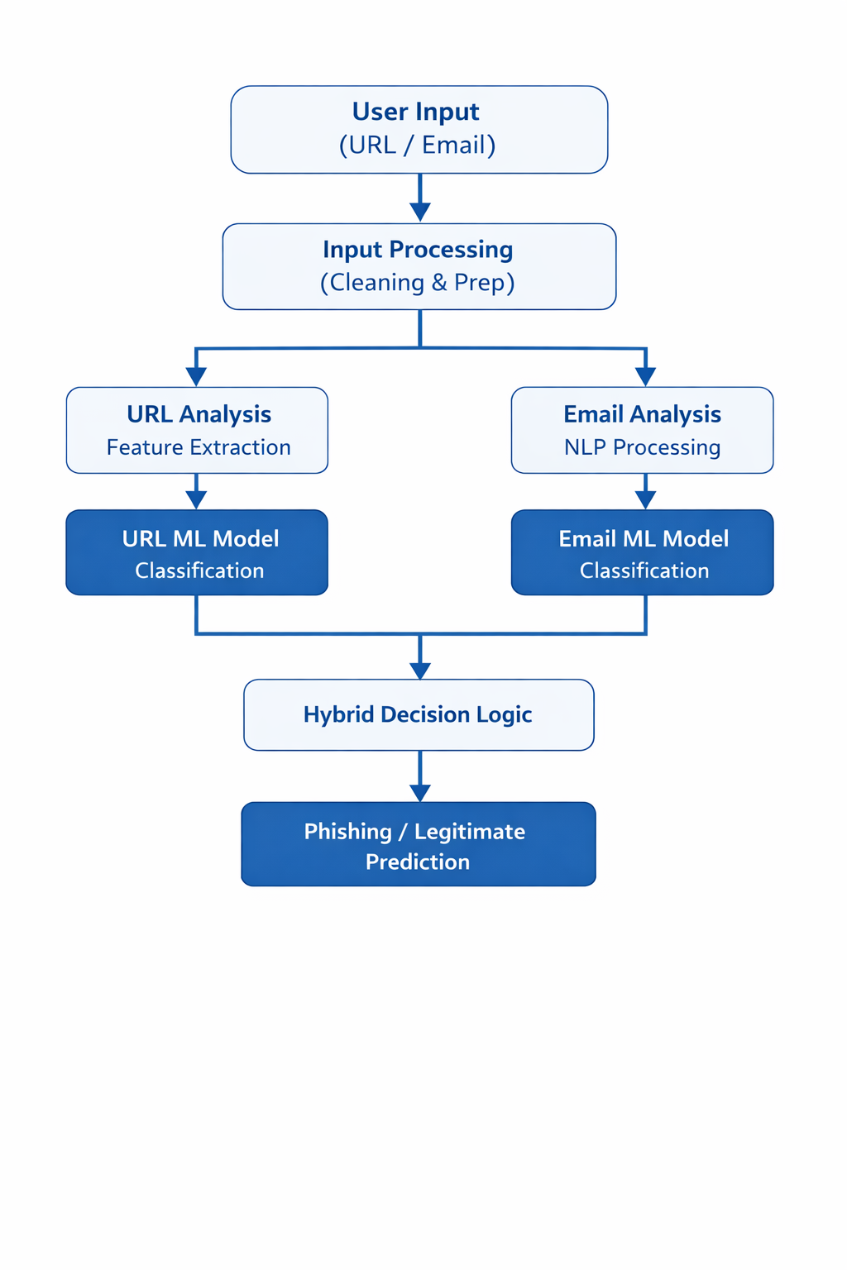
Figure 4.1: Architecture of the Hybrid Phishing Detection System.

4.3 URL Phishing Detection Model
The URL phishing detection model is used to classify URLs that may redirect users to phishing websites. Since phishing URLs often mimic legitimate websites, analyzing the structural properties of the URL can help classify it as legitimate or phishing.
The URL detection mechanism begins with analyzing the structure of the URL. Various features are identified in the URL string, such as the overall length of the URL, the presence of subdomains in the URL, and the length of the host name in the URL. Other features include the presence of suspicious characters and keywords in the URL.
After feature extraction, a machine learning model is trained using a dataset containing features that help distinguish phishing and legitimate URLs. The dataset contains samples of malicious and legitimate URLs. Each URL in the dataset is represented as a feature vector, where features are those identified in the URL.
In this stage, a machine learning model is trained to recognize patterns related to phishing activity by examining the features in the dataset. After completing this stage, a machine learning model is capable of classifying a URL as phishing or legitimate by examining features in the URL and comparing these features with those identified in the dataset.
For a given URL, feature extraction occurs, and a feature vector is generated. This feature vector is passed to a machine learning model, and a classification result is generated indicating whether it is a phishing URL or a legitimate URL.

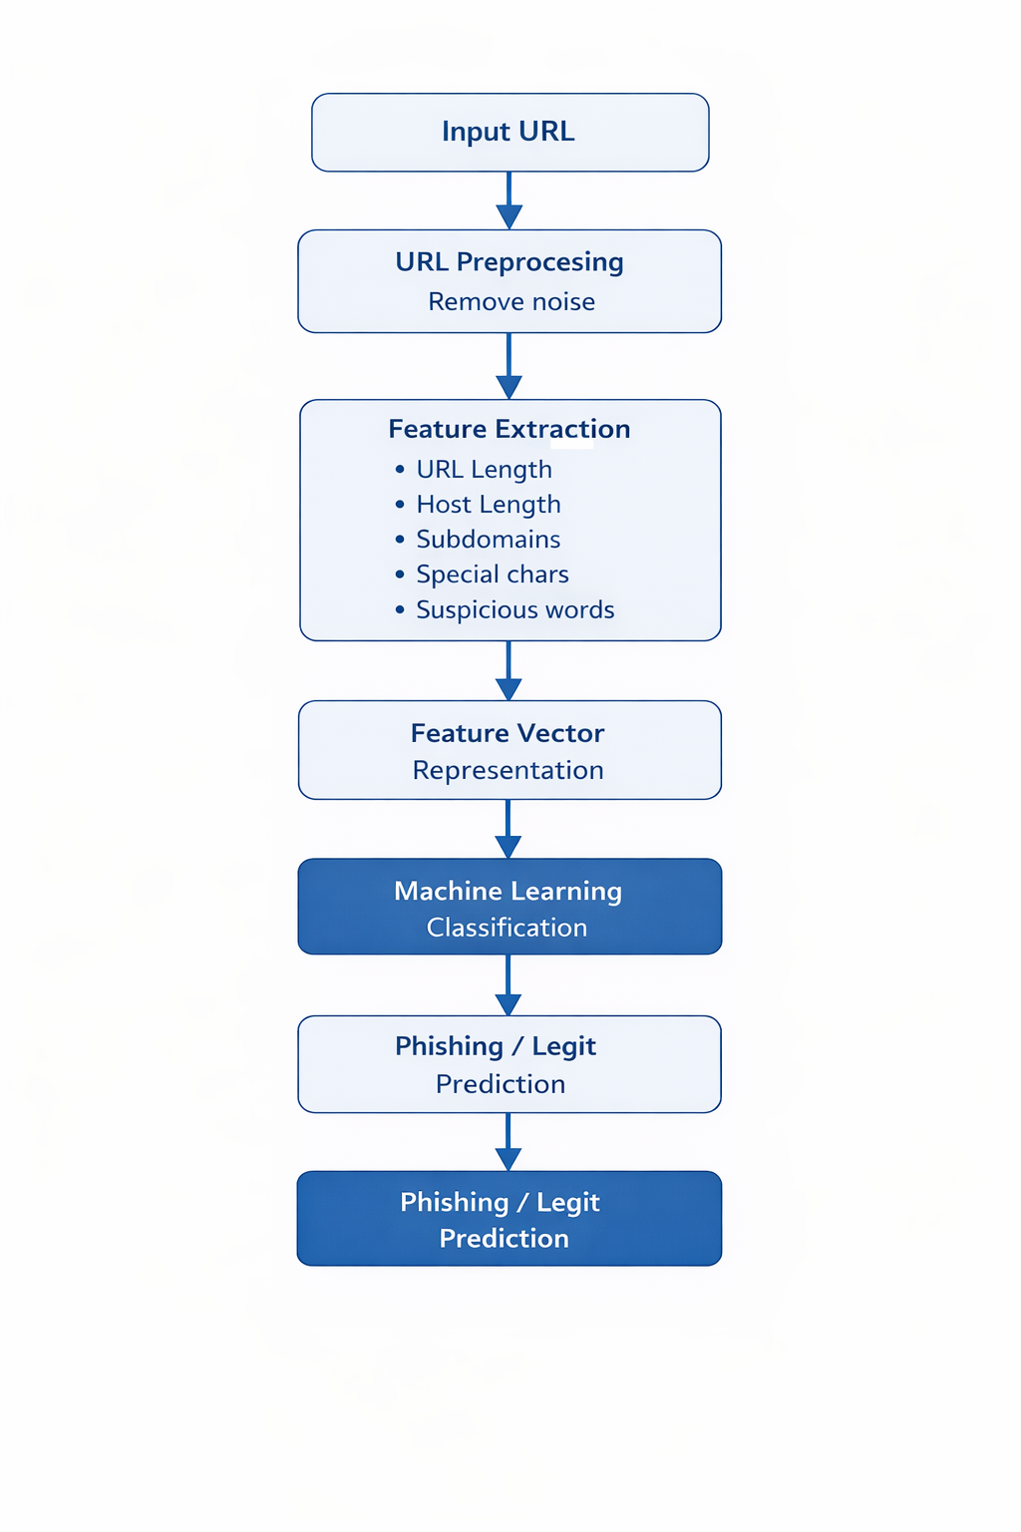

Figure 4.2: Workflow of the URL Phishing Detection Model.

4.4 Email Phishing Detection Model
Phishing emails are sent using psychological attacks to prompt users to take immediate action. Phishing emails are sent by attackers to trick users into revealing sensitive information such as login credentials and credit card numbers. Phishing emails are sent by attackers using psychological attacks to prompt users to take immediate action. Phishing emails are sent by attackers to trick users into revealing sensitive information such as login credentials and credit card numbers.
After this preprocessing, relevant features are identified in the email content. Such features could be word frequency patterns, phrases commonly found in phishing emails, and structural features of the email content. Feature representation techniques are employed to convert these features into a numerical format using techniques like vectorization.
Email Classification Model -
This model is trained using labeled data sets containing legitimate emails and phishing emails. During this stage, the model is trained using features and patterns in legitimate and phishing emails, enabling it to distinguish between legitimate emails and phishing emails.
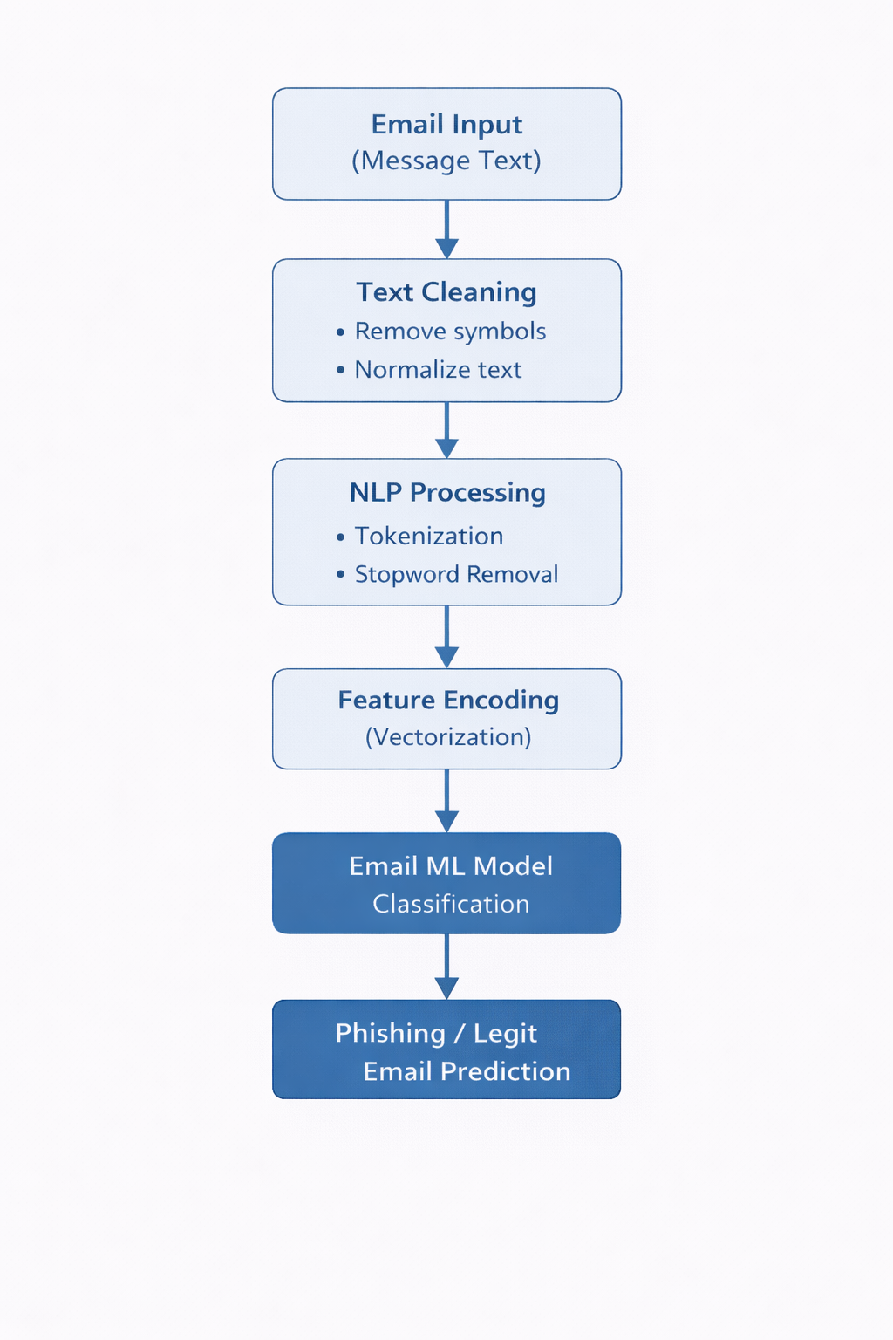

Figure 4.3: Email Phishing Detection Process.

4.5 Hybrid Detection Logic
Phishing attacks are carried out using a variety of techniques, and it is not uncommon to see a combination of techniques being employed in a phishing attack. For example, in a phishing email, a malicious URL could be embedded, redirecting the user to a phishing site masquerading as a legitimate site. To address this threat, it is necessary to analyze not only the email content but also the URL embedded in it.
This is addressed in this system by using a combination of the URL detection model and the email phishing detection model to arrive at a conclusion regarding the email content. Each model processes its input independently and arrives at a conclusion regarding whether it is suspicious or legitimate.
Based on this conclusion, if either of these models finds evidence of phishing activity, it is classified as a phishing attempt. This approach is useful in enhancing the phishing detection mechanism because it allows the system to identify different features commonly found in phishing emails.
The hybrid framework would therefore assist in the reduction of the occurrence of false negatives, as it would ensure that threats detected by the two modules are flagged for further investigation. By integrating different detection strategies into a single framework, the proposed method would offer a more comprehensive approach to detecting phishing attacks.

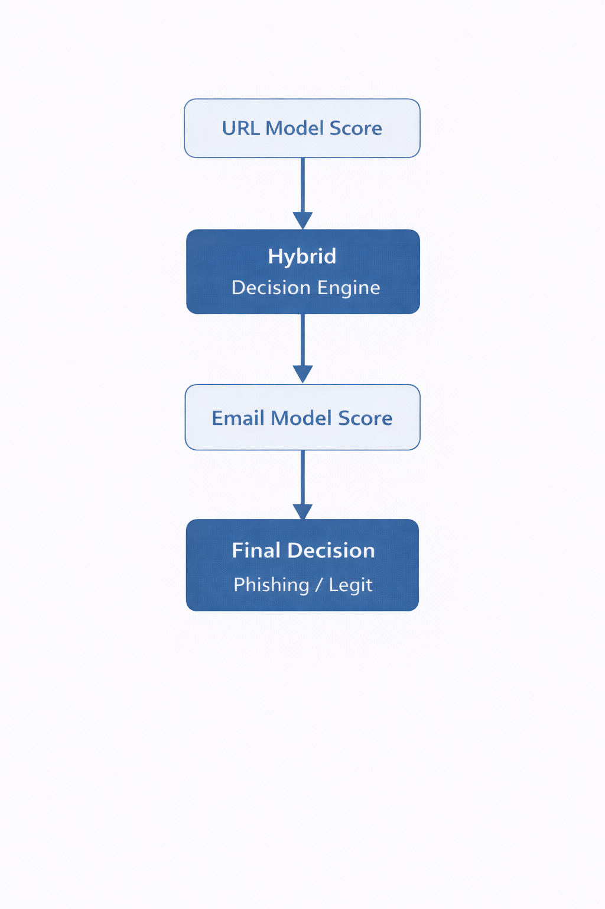
Figure 4.4: Hybrid Decision Mechanism for Phishing Detection.

4.6 Tools and Technologies Used
In the implementation of the phishing detection system, various software tools are utilized. To begin with, the system is implemented using the Python programming language due to its extensive use of data analysis and machine learning applications.
In the implementation of the machine learning algorithms, the system uses libraries such as Scikit-learn, which has efficient algorithms for classification. In addition, the library has tools for the evaluation of machine learning algorithms. Data preprocessing and feature extraction are done using libraries such as Pandas and NumPy, which offer powerful tools for handling large datasets.
In the implementation of the email detection module, natural language processing is done using text processing libraries, which offer the ability to transform text features into a numerical format for the machine learning algorithms.
In the implementation of the system, a modular structure is used, which would allow for the modification, improvement, or replacement of the different detection components.

CHAPTER 5

FACILITIES REQUIRED

5.1 Hardware Requirements
In order to develop the phishing detection system and conduct the required testing process, the following hardware requirements need to be met:
• Personal computer or laptop with a minimum of 8 GB RAM
• Multi-core processor like Intel i5 or any other high-performance processor
• Minimum of 50 GB storage capacity to store the required datasets and model files
• Internet connection to download the required datasets and access the required literature
These hardware requirements can fulfill the required needs to implement the phishing detection system.

5.2 Software Requirements
In order to develop the phishing detection system, the following software requirements need to be met:
• Operating System like Windows or Linux or macOS
• Programming language like Python
• Development environment like Jupyter Notebook or VS Code
• Libraries:
- Libraries like pandas and NumPy to process the required data
- Libraries like Scikit-learn to develop the required machine learning model
- Libraries like Natural Language Processing to evaluate the emails
These software requirements can fulfill the needs to implement the required phishing detection framework and develop the required machine learning model to evaluate the URL as well as emails.

REFERENCES

- AI Based Phishing Detection Techniques: A Comparative Analysis of Model Performance – https://www.researchgate.net/publication/400584536_AI_Based_Phishing_Detection_Techniques_A_Comparative_Analysis_of_Model_Performance
- The Role of Artificial Intelligence in Detecting and Preventing Phishing Emails – https://doi.org/10.5281/zenodo.14621440
- Hybrid Machine Learning Model for Phishing Detection – https://doi.org/10.1109/IS61756.2024.10705257
- Phishing Detection System Through Hybrid Machine Learning Based on URL – https://doi.org/10.1109/ACCESS.2023.3252366
- Across the Spectrum: In-Depth Review of AI-Based Models for Phishing Detection – https://doi.org/10.1109/OJCOMS.2024.3462503
- AI-Based Phishing Detection and Student Cybersecurity Awareness in the Digital Age – https://doi.org/10.1109/OJCOMS.2024.3462503
- A Deep Learning-Based Phishing Detection System Using CNN, LSTM, and LSTM-CNN – https://doi.org/10.3390/electronics12010232
- Hybrid AI Models for Phishing URL Detection: A Unified Approach to Mitigating Cyber Threats – https://eudoxuspress.com/index.php/pub/article/view/3026
- Neurosymbolic Learning and Domain Knowledge-Driven Explainable AI for Enhanced IoT Network Attack Detection and Response – https://doi.org/10.1016/j.cose.2025.104318

